COLLEGE OF THE SEQUOIAS COMMUNITY COLLEGE DISTRICT
Board of Trustees Meeting
August 11, 2014

ANNUAL REPORT ON DISTANCE EDUCATION

Status: Information

Presented by: Jennifer Vega La Serna, Ph.D.
Vice President, Academic Services

Issue

Deborah L. Nolan, Ph.D., Distance Education and Faculty Enrichment Coordinator, will present the annual report on Distance Education.

Background

Dr Nolan will update the Board of Trustees on Distance Education at College of the Sequoias, including Blackboard, course offerings, faculty certification, and student success.

Recommended Action

No action is required.

Blackboard (Bb)

Usage
Bb usage continues to increase. We had 384 active Bb classes in the spring of 2013 and 437 in spring of 2014.
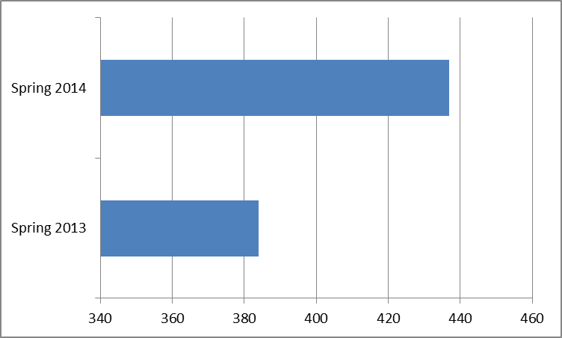

Support for Students and Faculty

A relatively small number of students experience difficulty getting started with Bb the first time. To help students, we have developed a number of support structures. The general online orientation to COS contains information about Bb (and online classes). In addition, students can find login information online in text and video tutorial format or get help logging in at the Student Helpdesk in the library or Welcome Center. Dr Nolan also provides one-to-one student support as needed and gives face-to-face orientations in classrooms when invited to do so.

New instructors are given an orientation to Bb in their first semester at the new faculty orientation and other faculty development activities facilitated by Dr Nolan. In addition, Dr Nolan provides Bb training and management support to faculty on a daily basis. This year, Dr Nolan published a weekly email newsletter entitled, “A Better Blackboard: Tips for Maximizing your Blackboard Experience.” Quite a number of veteran instructors contacted her as a result of receiving the newsletter and expressed new interest in getting started with Bb.

In the event of a rare technical problem with Bb, Computer Services employee, Jeremy Tierce, is contacted. He has a very rapid response and a 100% success rate solving our technical problems

Upgrade

The Academic Senate subcommittee for distance education, DECOS, recommended to the Senate that we upgrade our Bb system to a new service pack level over the summer, and the recommendation was approved by the Academic Senate and supported by the District. The upgrade was scheduled to occur between the end of the summer term and the beginning of the fall term. During the spring semester, Dr Nolan provided many training sessions for the faculty so that they could learn about the new features developed for our new “version” of Bb. Most of the changes are cosmetic in nature, but several of the most popular Bb features have major improvements. The transition to the new version of Bb is expected to be very easy for instructors. There is expected to be little to no negative effect on students with the transition. The faculty, Student Helpdesk, and Welcome Center are poised to assist students with the transition should there be any need.

Online Classes

Divisions across campus continue to schedule online classes, including Business, Consumer Family Studies, English/Fine Arts, I&T, Math, Counseling, Fire Technology, Library, Nursing, and Social Sciences. Instructors schedule classes in three main formats: (1) entirely online; (2) online with orientation; and (3) hybrid (requiring scheduled meetings in addition to online activity). The table below indicates the number of sections offered in the Spring 2013, Spring 2014, Summer 2014, Fall, 2013, and those scheduled for Fall 2014.

 | Online Sections
Spring 2013 | 85
Spring 2014 | 96

 | Online Sections
Summer 2013 | 0
Summer 2014 | 20

 | Online Sections
Fall 2013 | 91
Fall 2014 (scheduled) | 93

Online Teaching Certification Program

60 instructors have completed the Online Teaching Certification Program since 2011.

Student Success

According to data from the Fall 2013 semester, 48.8% of our online classes had a better success rate or fell within 10% of the face-to-face counterpart, 44.2% have between 11% and 29% lower success than face-to-face, and 7% have a range of between 30% and 45% lower success rates than their face-to-face counterparts. We are continuing to identify the factors that influence student success, but it is apparent that there are some things related to student preparation that we can fix and some things we can’t fix. Five considerations related to student success that we have identified are as follows:

- Awareness
  - Students must be aware that they are registering for an online class and that it won’t be easier than a face-to-face class. A recent survey of online students (Spring 2014) indicated as many as 30% of students thought the class would be easier than a face-to-face class.
- Expectations
  - Students who have a compelling reason to finish a class tend to be more successful in the class.
- Skills
  - Students should have basic computer skills.
  - Students should have strong time management skills
- Dispositions
  - Students tend to be successful if they:
    - Are able to set and achieve goals.
    - Are comfortable troubleshooting computer problems.
    - Do not mind being separated from their instructors and classmates.
    - Prefer reading instructions to listening to them.
    - Monitor their COS email regularly.
    - Know when they need help and know how to ask for it.
- Situation
  - Students who have a GPA above 2.0 and have taken an online class before tend to be more successful.
  - Students who have support outside of school tend to be more successful.

We have made an effort to support student awareness of the difference between online and face-to-face classes by continuing to send pre-course messages to students and giving them tips to being successful. Additionally, this year, we have developed and launched an online class registration confirmation mechanism in Banner that alerts students to the fact that they are registering for an online class and that online learning has some important differences about which students should be aware.

For those factors related to student success involving expectations, skills, dispositions, and situation that we can’t control, we can at least help students and faculty become aware of the factors and provide support whenever possible. Based on an analysis of research related to student success in online classes, Dr Nolan developed and piloted a student online learning readiness survey at the end of the spring 2014 semester. All summer 2014 and fall 2014 instructors were invited to administer the survey in their classes to help them and their students understand student readiness levels and provide interventions accordingly. A copy of the survey is provided below for your information.

Student Online Learning Readiness Survey
Question | I knew that this was an online class when I registered for it.
Answer | 1. Yes  2. No  3. Not sure
Question | It was very important for me to pass this class.
Answer | 1. Strongly Agree  2. Agree  3. Disagree  4. Strongly Disagree
Question | I was interested in the class because I thought online classes were easier than face-to-face classes.
Answer | 1. Strongly Agree  2. Agree  3. Disagree  4. Strongly Disagree
Question | I have good computer skills.
Answer | 1. Strongly Agree  2. Agree  3. Disagree  4. Strongly Disagree
Question | This course is very relevant to my educational goals.
Answer | 1. Strongly Agree  2. Agree  3. Disagree  4. Strongly Disagree
Question | I am someone who likes to set goals and work to achieve them.
Answer | 1. Strongly Agree  2. Agree  3. Disagree  4. Strongly Disagree
Question | I manage my time well.
Answer | 1. Strongly Agree  2. Agree  3. Disagree  4. Strongly Disagree
Question | I have regular access to a computer with Internet service.
Answer | 1. Strongly Agree  2. Agree  3. Disagree  4. Strongly Disagree
Question | I have taken an online class before this one.
Answer
  Yes
  No
Question | When it comes to using a computer, I can usually figure out how to do what I need to do without asking for help.
Answer | 1. Strongly Agree  2. Agree  3. Disagree  4. Strongly Disagree
Question | When it comes to doing my college course-work, I feel that I have support from friends and, or family.
Answer | 1. Strongly Agree  2. Agree  3. Disagree  4. Strongly Disagree
Question | I prefer being in the same room at the same time with my classmates and instructor instead of being separated from them.
Answer | 1. Strongly Agree  2. Agree  3. Disagree  4. Strongly Disagree
Question | I do not mind being separated from my classmates and instructor while taking the class.
Answer | 1. Strongly Agree  2. Agree  3. Disagree  4. Strongly Disagree
Question | I prefer hearing my instructor tell me assignment instructions instead of reading them.
Answer | 1. Strongly Agree  2. Agree  3. Disagree  4. Strongly Disagree
Question | I prefer reading instructions instead of listening to instructions.
Answer | 1. Strongly Agree  2. Agree  3. Disagree  4. Strongly Disagree
Question | I monitor my COS email regularly.
Answer | 1. Yes  2. No
Question | I usually know when I need help and am comfortable asking for help when I need it.
Answer | 1. Strongly Agree  2. Agree  3. Disagree  4. Strongly Disagree
Question | My GPA is above 3.0.
Answer
  Yes
  No
Question | My GPA is between 2.0 and 2.9.
Answer
  Yes
  No
Question | My GPA is below 2.0.
Answer
  Yes
  No
Question | I want to transfer to a four-year college.
Answer
  Yes
  No
Question | When the class started, I knew how to use Blackboard.
Answer | 1. Strongly Agree  2. Agree  3. Disagree  4. Strongly Disagree
Question | I would have attended a "how to use Blackboard" workshop at COS when the class began.
Answer
  Yes
  No
Question | If you indicated in the question above that you would have liked to attend a Blackboard workshop, please indicate if you would have been interested in a morning, afternoon, evening, weekday or Saturday workshop.
Question | Is there anything else you would like to share with me about being successful in an online class?

